CHAPTER – 5
SYSTEM DESIGN
5.1 System Architecture
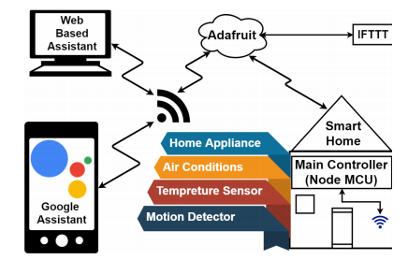

5.2 Control flow Diagram
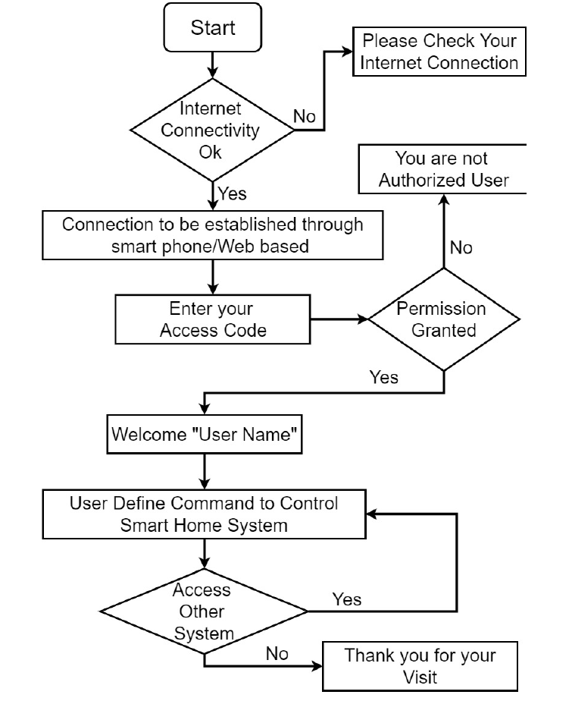

5.3 Sequence Diagram
